Assignment 2- Cyber Security

Command prompt:

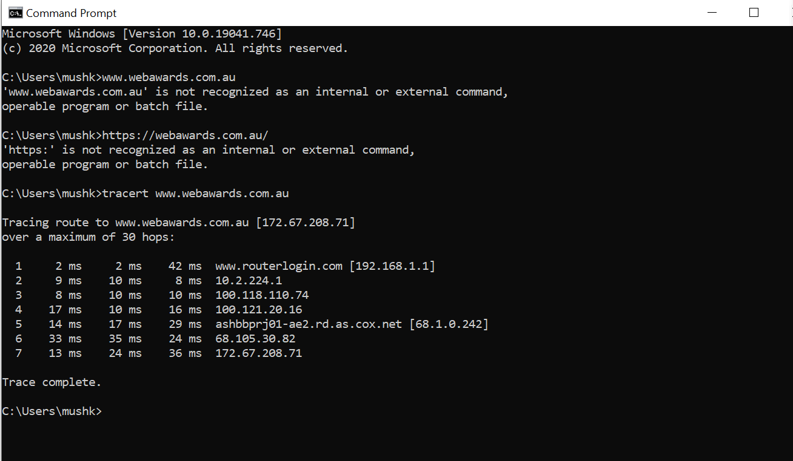

|  |  |  |  |
| --- | --- | --- | --- |
| HOP COUNT | IP ADDRESS | ORGANIZATION (IP OWNERS) | LOCATION |
| 1 | [192.168.1.1] | IANA- INTERNET ASSIGNED NUMBER AUTHORITY | LOS ANGELES, CA, USA |
| 2 | 10.2.224.1 | IANA- INTERNET ASSIGNED NUMBER AUTHORITY | LOS ANGELES, CA, USA |
| 3 | 100.118.110.74 | IANA- INTERNET ASSIGNED NUMBER AUTHORITY | LOS ANGELES, CA, USA |
| 4 | 100.121.20.16 | IANA- INTERNET ASSIGNED NUMBER AUTHORITY | LOS ANGELES, CA, USA |
| 5 | 68.1.0.242 | COX-COMMUNICATION INC. | ATLANTA, GA, USA |
| 6 | 68.105.30.82 | CXA- COX COMMUNICATION INC. | ATLANTA, GA, USA |
| 7 | 172.67.208.71 | CLOUD14- CLOUDFLARE, INC. | SAN FRANCISO, CA, USA |
| 8 | 122.129.218.218 | WEB-PROPHETS-AU | AUSTRALIA |

Command prompt: